Product:**Savlon Active Gel Hand Sanitizer Bottle  (8 x 100 ml)**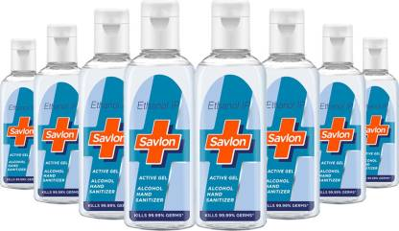

**Price:**₹400**User Rating**4.4**Delivery Status:**13 Jun, Saturday**Available Offers:**Bank Offer5% Unlimited Cashback on Flipkart Axis Bank Credit CardT&CBank OfferExtra 5% off* with Axis Bank Buzz Credit CardT&CNo Cost EMI on Flipkart Axis Bank Credit CardT&C**Highlights:**Hand SanitizerIdeal For: Men & WomenQuantity: 800 mlBottle ContainerFresh Fragrance